DAY – 1 DATA STRUCTURES PROGRAMS

1. Write a C program to find the given number is Even or Odd

Code:

#include<stdio.h>

int main(){

int n;

printf("Enter any positive number: ");

scanf("%d", &n);

if(n%2==0)

printf("The number is even");

else

printf("The number is odd");

return 0;

}

Sample input: 5

Output: The number is odd.

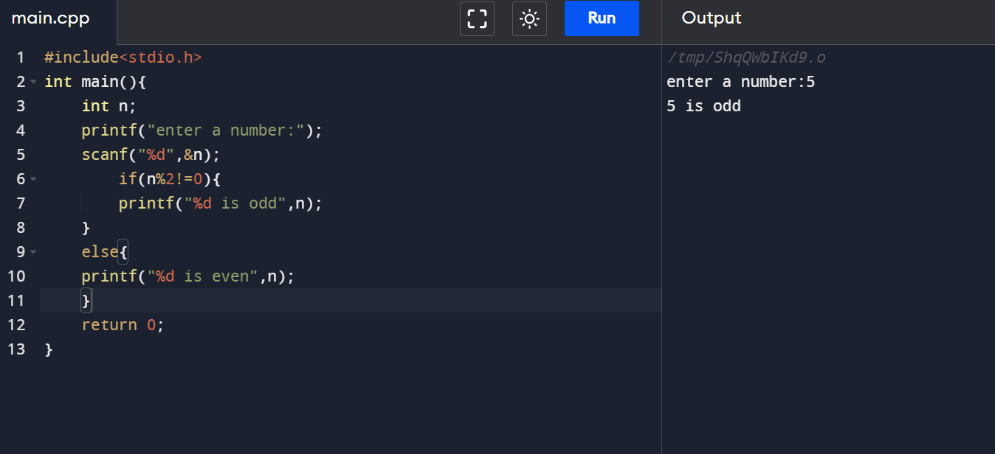

1. Write a c program to find sum of first n numbers using any loop?

Code:

#include<stdio.h>

int main(){

int n, i, sum = 0;

printf("Enter any number: ");

scanf("%d", &n);

for(i = 1; i<= n; ++i){

sum += i;

}

printf("The sum of first n numbers is : %d\n", sum);

return 0;

}

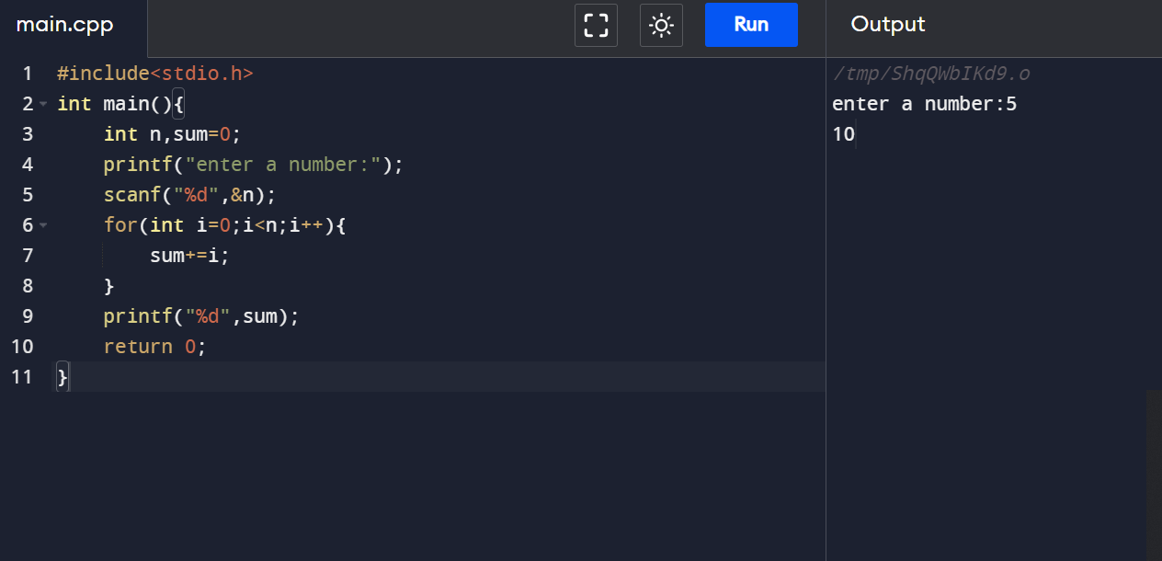

Sample input = 5

Output : sum = 15

1. Write a C program to find sum of even numbers with first n numbers?

Code:

#include<stdio.h>

int main(){

int n, i, sum = 0;

printf("Enter any limit: ");

scanf("%d", &n);

for(i = 2; i<= n; i+=2){

sum += i;

}

printf("The sum of first n even numbers from 1 to %d : %d", n, sum);

return 0;

}

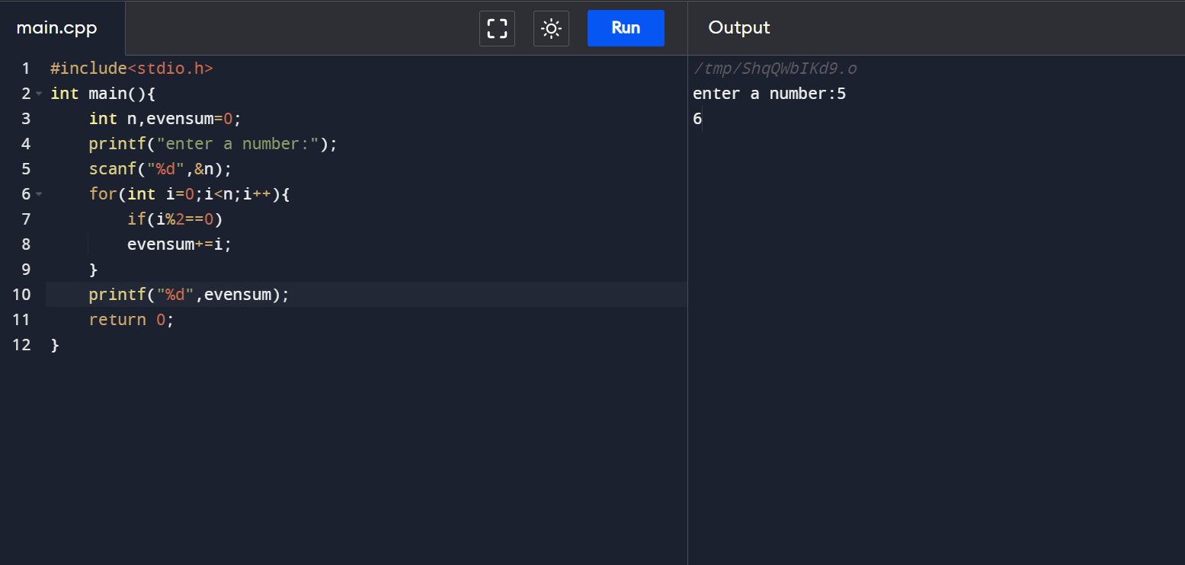

Sample input : 5

Output: The sum of first n even numbers from 1 to 5: 6

1. Write a C program to find sum of odd numbers the first n numbers?

Code:

#include<stdio.h>

int main(){

int n, i, sum = 0;

printf("Enter the limit: ");

scanf("%d", &n);

for(i = 1; i<=n; i++){

if(i % 2 != 0){

printf("%d\n", i);

sum = sum + i;

}

}

printf("The sum of Odd numbers from 0 to %d is: %d", n, sum);

return 0;

}

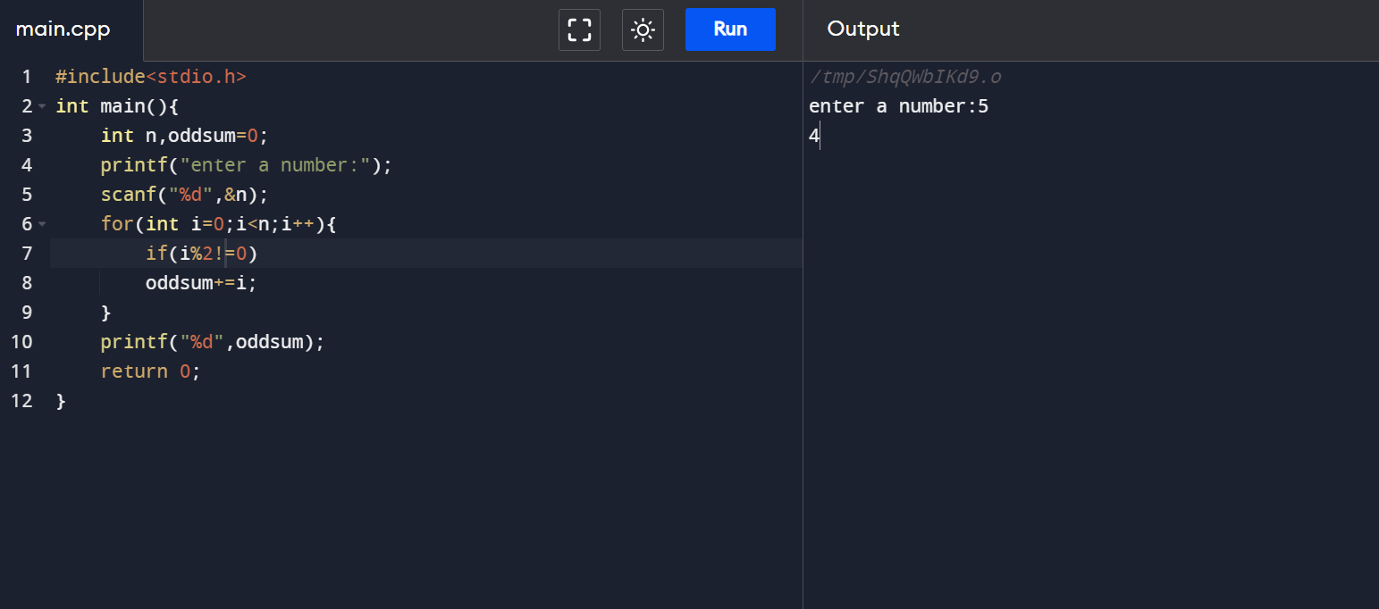

Sample input: 5 and Output: 9

1. Write a C program to find the factorial of a given number with Recursion?

Code:

#include<stdio.h>

int fact(int n){

if(n == 1){

return n;

}

return n\*fact(n-1);

}

int main(){

int n;

printf("Enter any positive number: ");

scanf("%d", &n);

printf("%d", fact(n));

} 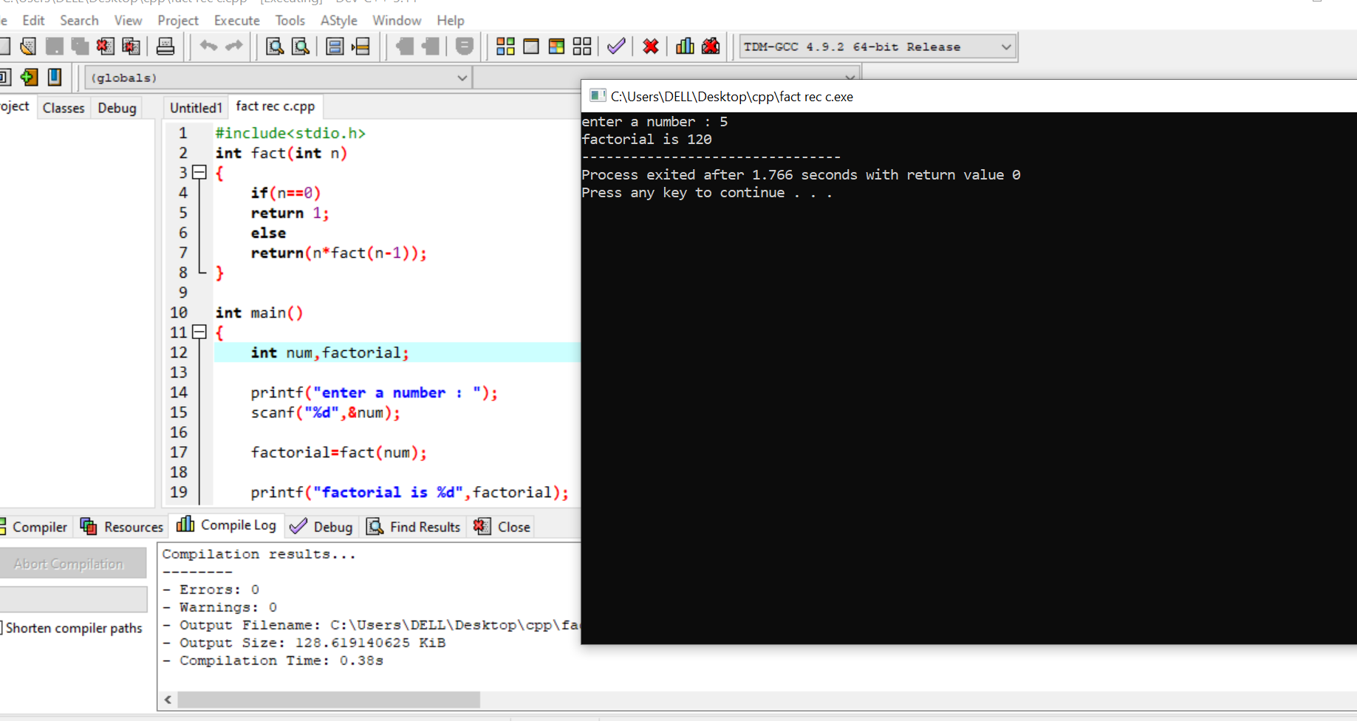

Sample input: 5

Output : 120

1. Write a C program to find the factorial of a given number without Recursion?

Code:

#include<stdio.h>

int main()

{

int n,i,fact=1;

printf("Enter any number: ");

scanf("%d", &n);

for(i = 1; i<= n; i++){

fact = fact \* i;

}

printf("The factorial of %d is : %d", n, fact);

return 0;

}

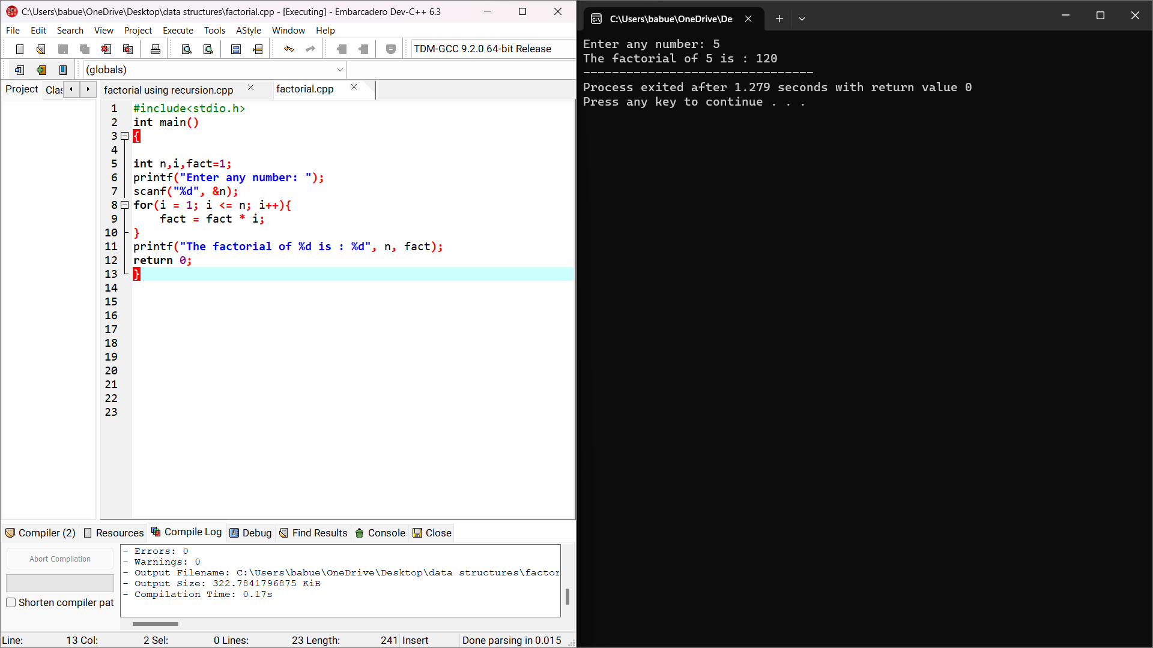

Sample input :5

Output: 120

1. Write a C program to find or to generate Fibonacci series?

Code:

#include<stdio.h>

int main(){

int n1 = 0, n2 = 1, n3, i, number;

printf("Enter the number of elements : ");

scanf("%d", &number);

printf("\n%d%d", n1,n2);

for(i = 2; i< number; ++i){

n3 = n1 + n2;

printf("%d", n3);

n1 = n2;

n2 = n3;

}

return 0;

}

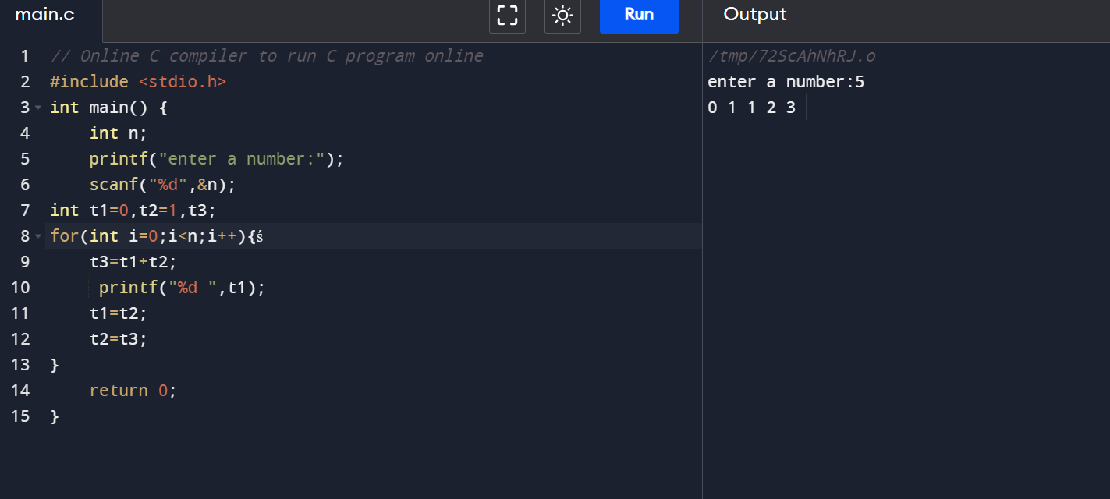

Sample input: 15

Output : 0 1 1 2 3 5 8 13 21 34 55 89 144 233 377.

8)Write a C program to generate Fibonacci series with recursion?

Code:

#include<stdio.h>

int fi(int n){

if(n == 0){

return 0;

}

else if(n == 1){

return 1;

}

else{

return(fi(n-1)+fi(n-2));

}

}

int main(){

int fi(int n);

int n, i = 0, c;

scanf("%d", &n);

printf("fibonacci series \n");

for(int c=1;c<=n;c++){

printf("%d", fi(i));

i++;

}

return 0;

}

Sample input : 15

Output: 0 1 1 2 3 5 8 13 21 34 55 89 144 233 377.

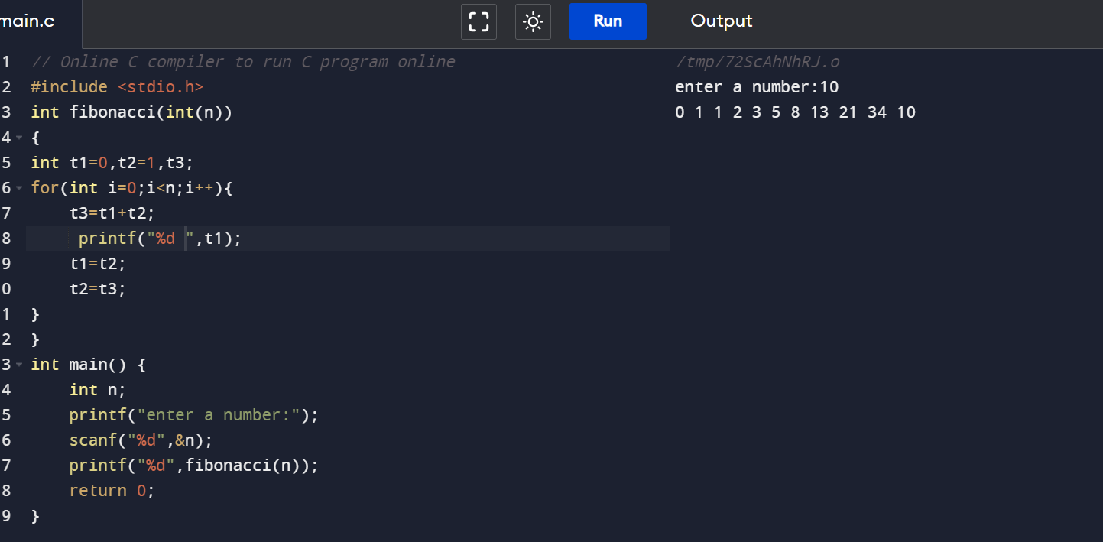

9)Write a C program to reverse a given number?

Code:

#include<stdio.h>

int main(){

int n, reverse = 0, remainder;

printf("Enter any number: ");

scanf("%d", &n);

while(n != 0){

remainder = n % 10;

reverse = reverse \* 10 + remainder;

n /= 10;

}

printf("Reversed number = %d", reverse);

return 0;

}

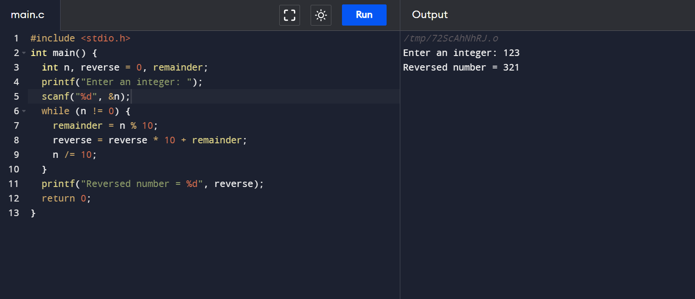

Sample input: 75

Output: 57

10) Write a C program to check palindrome or not?

Code:

#include<stdio.h>

int main()

{

int n, r, sum = 0, temp;

printf("Enter the number: ");

scanf("%d", &n);

temp = n;

while(n>0){

r = n%10;

sum = (sum\*10)+r;

n = n/10;

}

if(temp==sum)

printf("Palindrome number");

else

printf("not palindrome");

return 0;

}

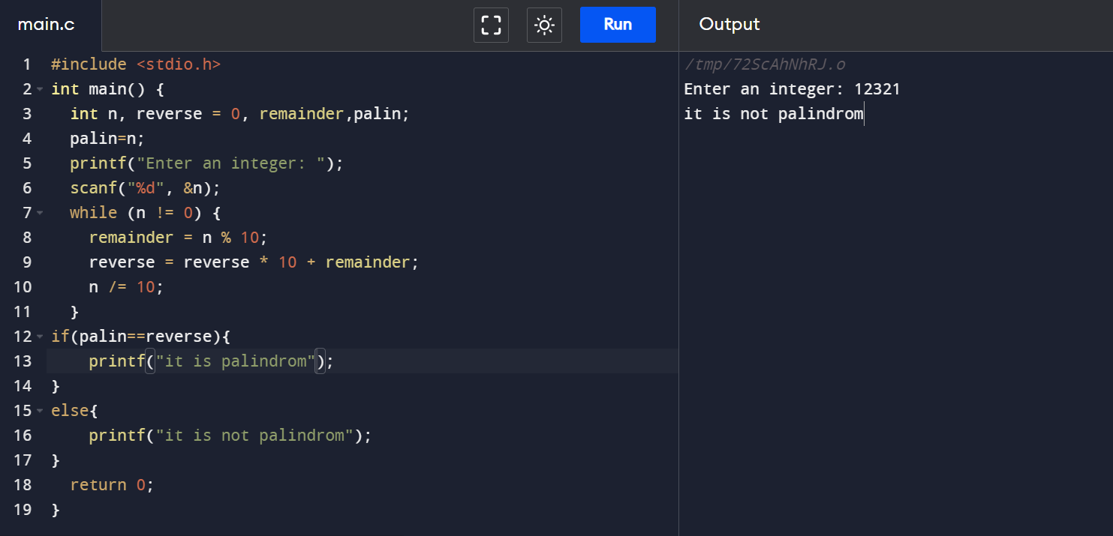

Sample input:575

Output: It is palindrome number.

11) Write a C program to check the given Armstrong or not?

Code:

#include<stdio.h>

int main()

{

int num, originalnum, rem, res=0;

printf("Enter a three digit number: ");

scanf("%d", &num);

originalnum = num;

while(originalnum != 0){

rem = originalnum % 10;

res += rem \* rem \* rem;

originalnum /= 10;

}

if(res == num)

printf("%d is an armstrong number", num);

else

printf("%d is not an armstrong number", num);

return 0;

}

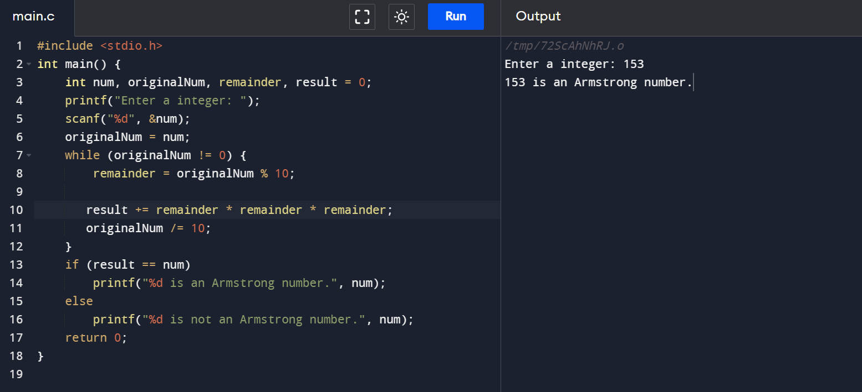

Sample input: 153

Output: It is Armstrong number.